NAME : DIVYADHARSHINI G
DEPARTMENT : BSC DATA SCIENCE & ARITIFICIAL INTELLIGENCE
ROLL NO : E25DA016

POWER BI
STEP : 1
Open Power BI
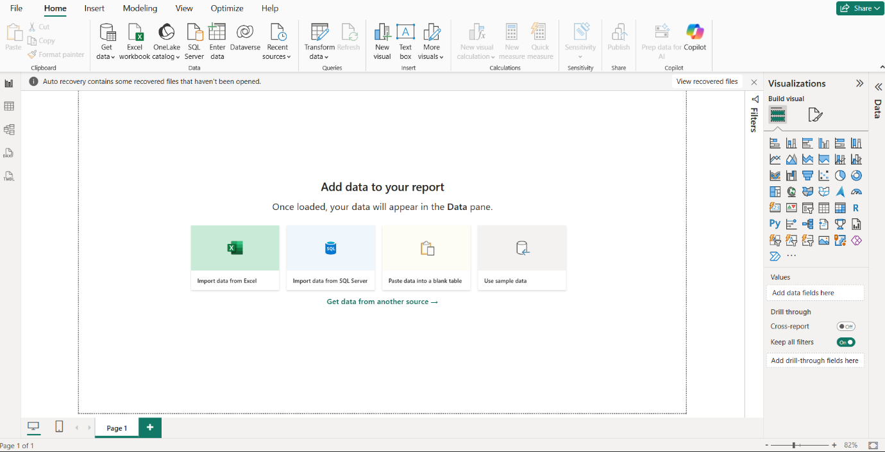

STEP : 2
Load the dataset and click transform data
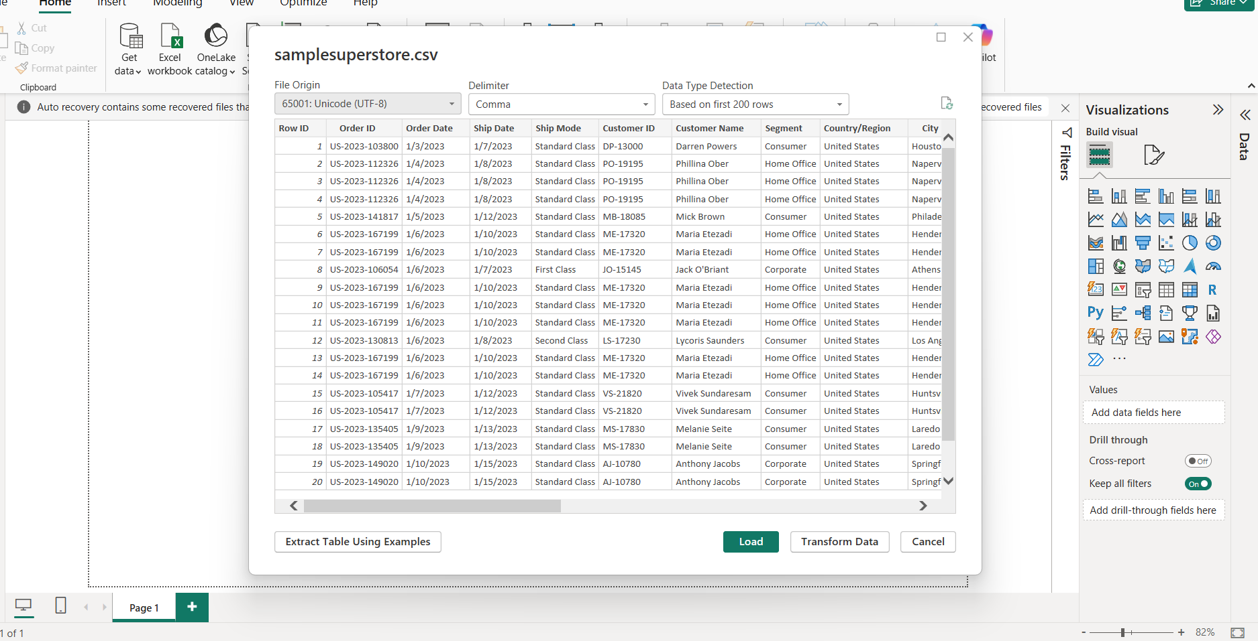
STEP : 3
Change the order date and ship date using locale

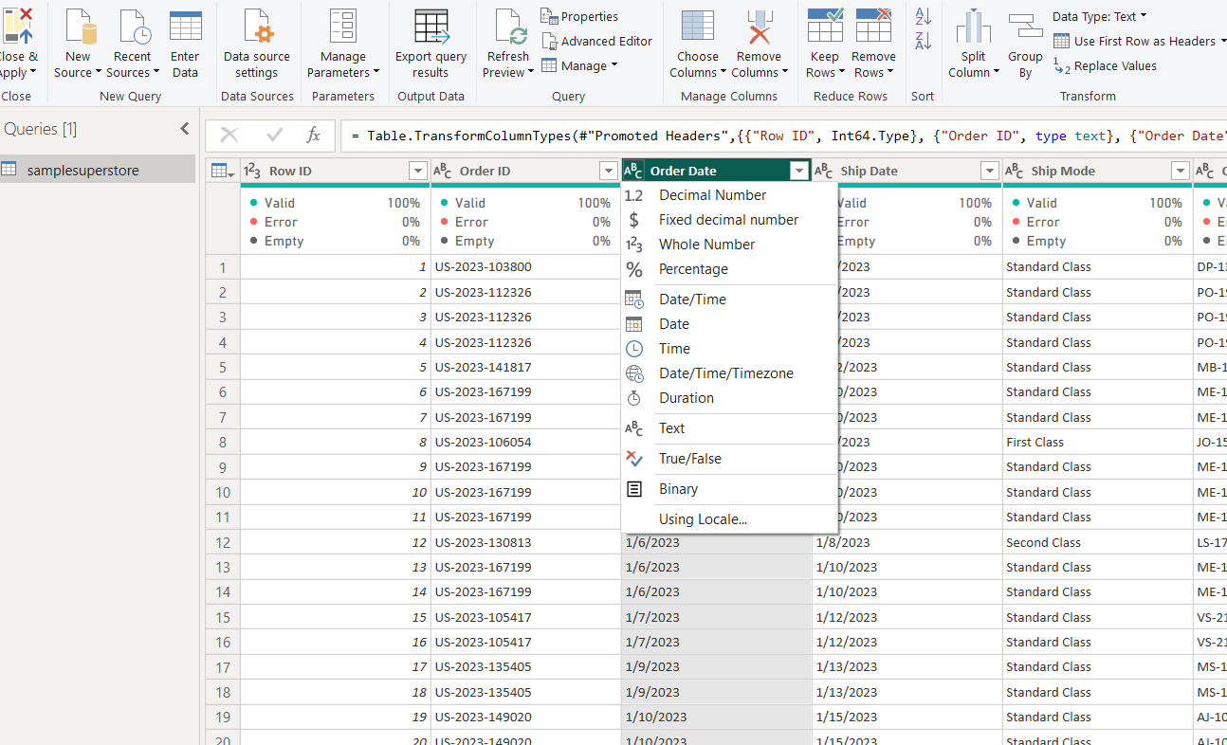

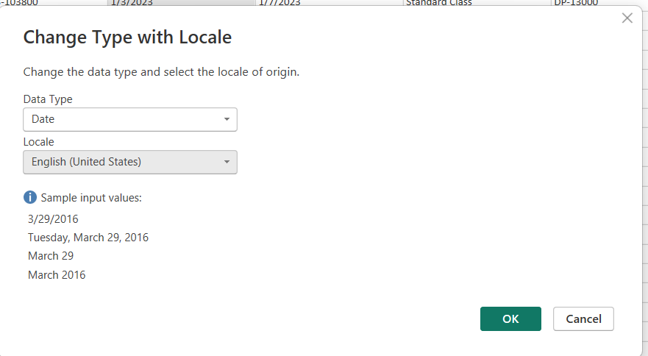
Same for ship date
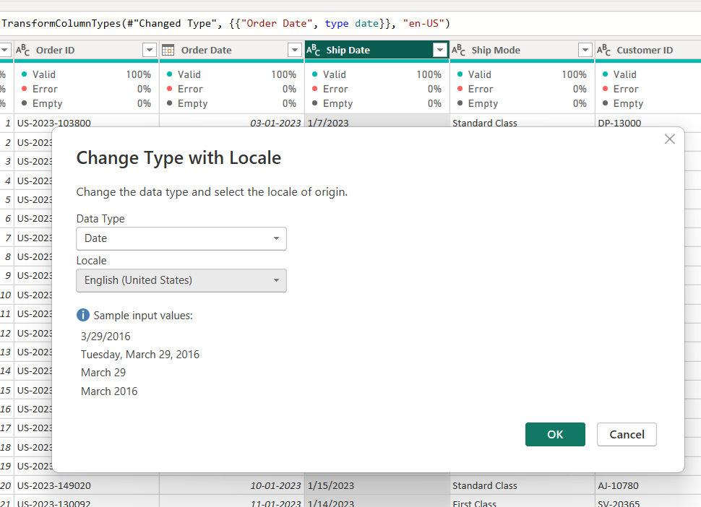
STEP : 4
Checking missing values using view and column quality
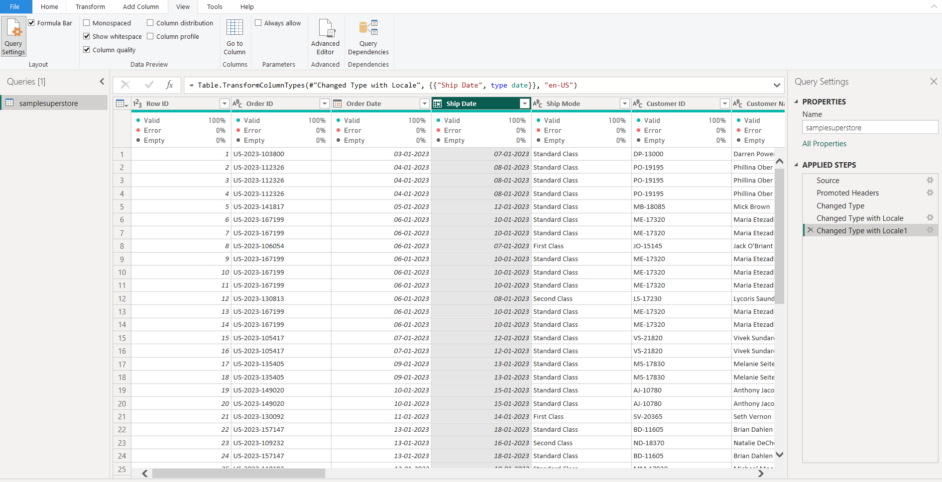
STEP : 5
Removing duplicates
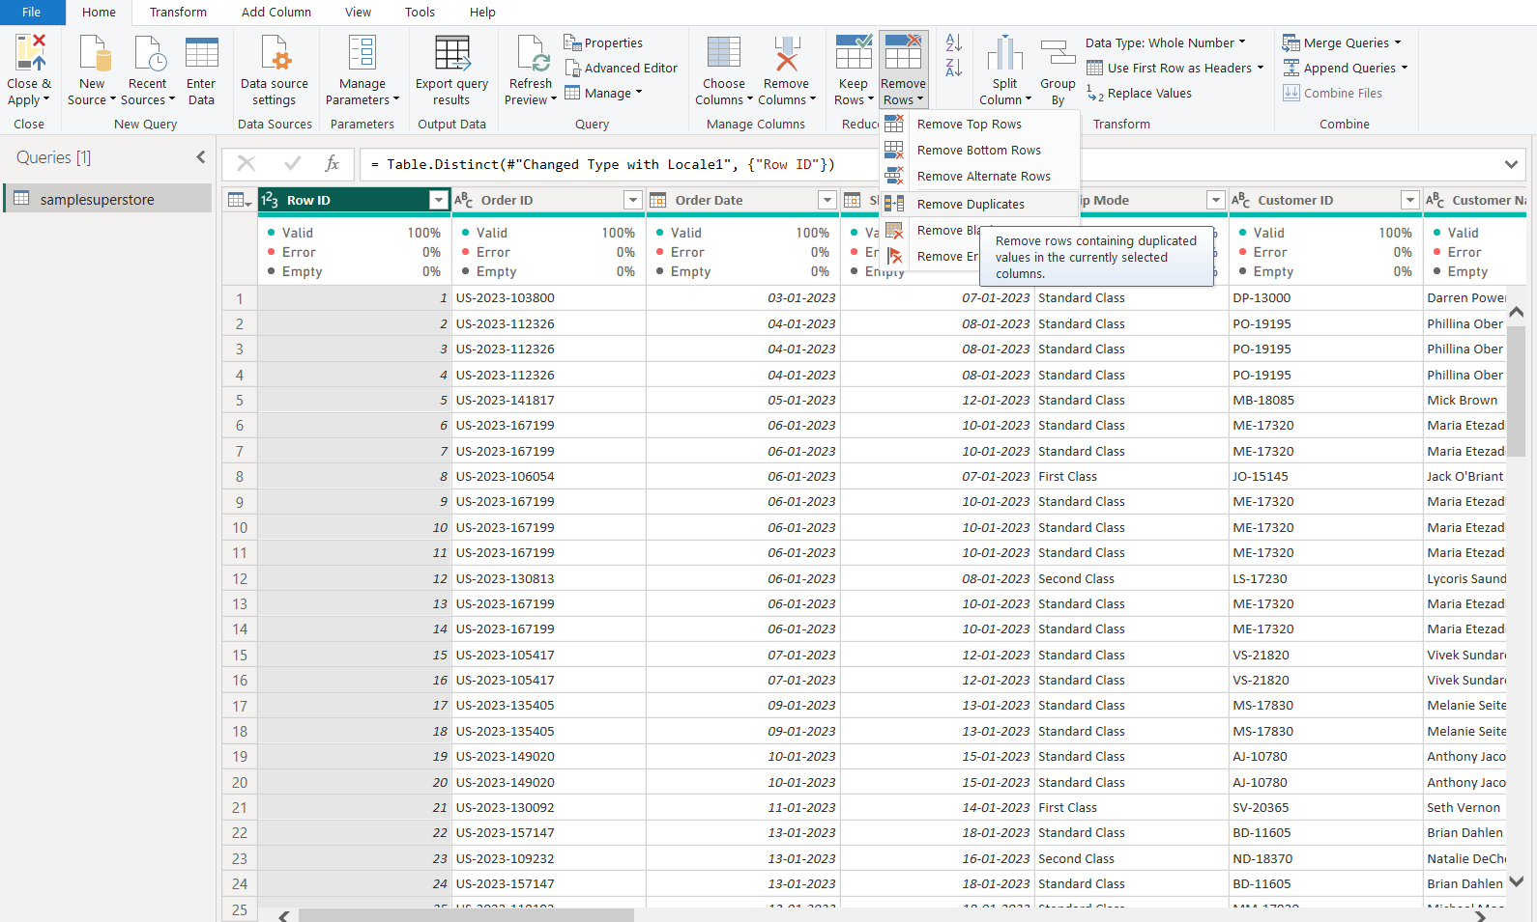
STEP : 6
Create year column and name of day
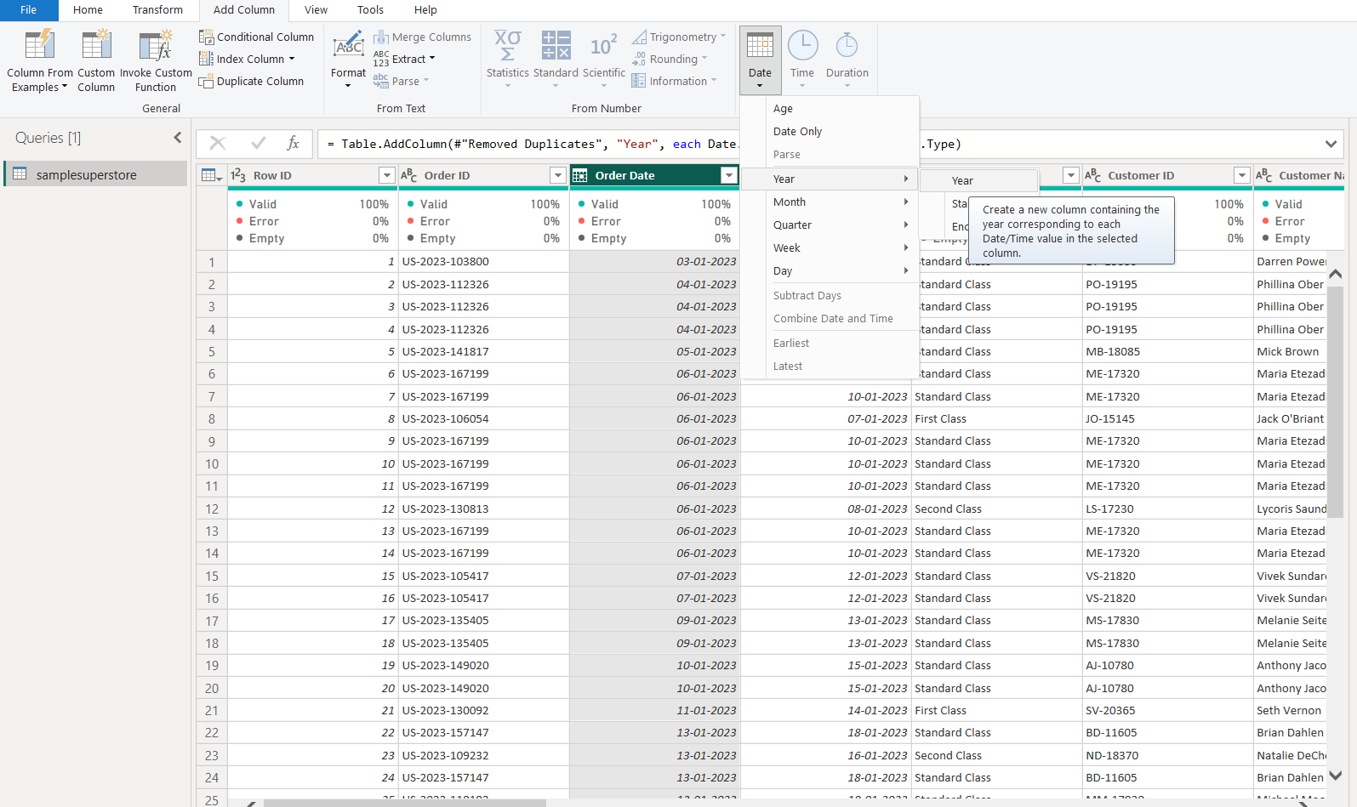
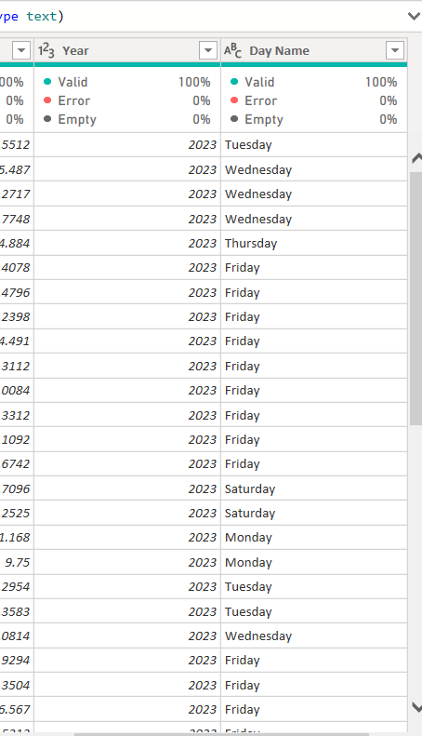
STEP : 7
Close and apply
